DBMS ASSIGNMENT

NAME : AJITH E JOEMON
COURSE : MSc CS (Data Analytics)
ROLL NO : 03

ER DIAGRAM

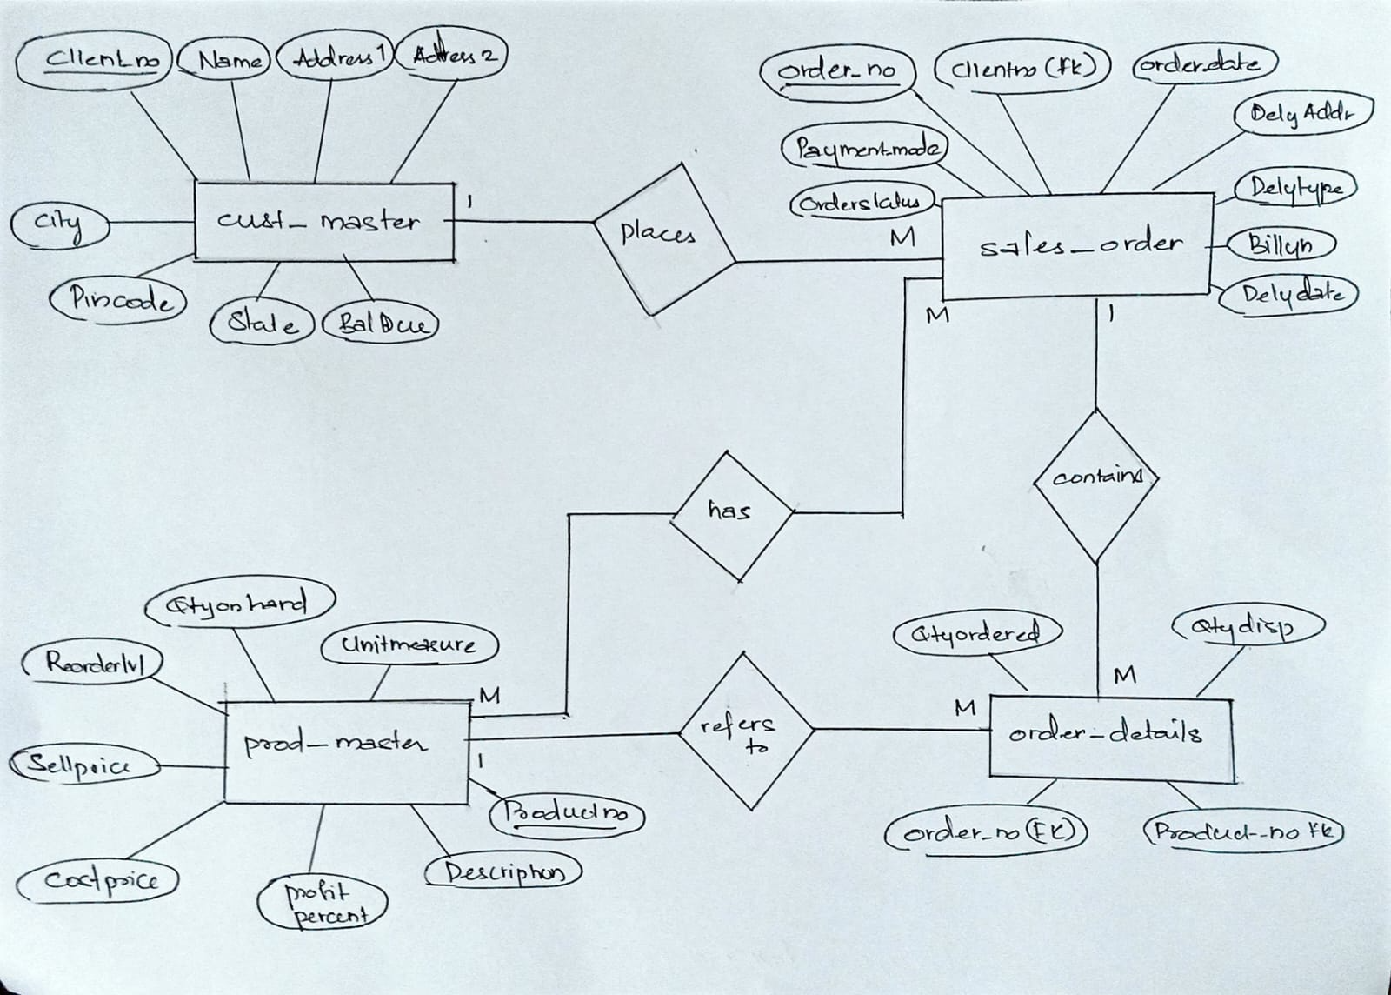

create table cust_master
(
clientno varchar2(6) primary key constraint chk_frst_letter check(clientno like 'C%'),
name varchar2(20) not null,
adress1 varchar2(30),
adress2 varchar2(30),
city varchar2(15),
pincode number(8),
state varchar2(15),
baldue number(10,2)
);
table cust_master created.
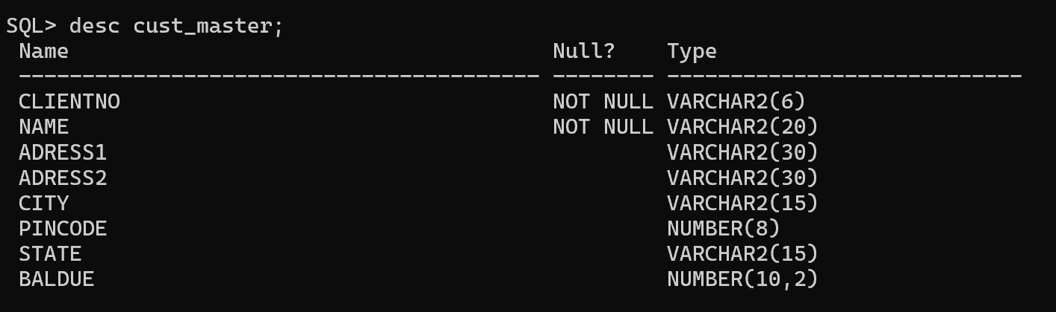

create table prod_master
(
productno varchar2(6) primary key constraint chk_product_id check (productno like 'P%'),
description varchar2(15) not null,
profitpercent number(4,2) not null,
unitmeasure varchar2(10) not null,
qtyonhand number(8) not null,
reorderlvl number(8) not null,
sellprice number(8,2) not null constraint chk_sell_zero check (sellprice <> 0),
costprice number(8,2) not null constraint chk_cost_zero check (costprice <> 0)
);
table prod_master created.

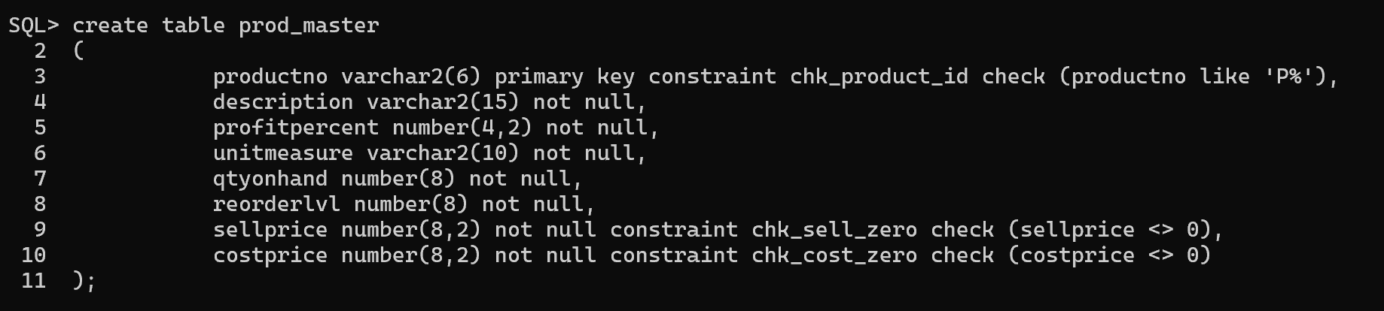

create table sales_order
(
orderno varchar2(6) primary key constraint chk_order_id check (orderno like 'o%'),
clientno varchar2(6) references cust_master(clientno),
orderdate date not null,
delyaddr varchar2(25),
delytype char(1) default 'f' constraint chk_delytype check (delytype in ('p', 'f')),
billyn char(1),
payment_mode varchar2(15) constraint chk_payment check (payment_mode in ('cod', 'net banking', 'credit card', 'debit card')),
delydate date,
orderstatus varchar2(10) constraint chk_status check (orderstatus in ('in process', 'fulfilled', 'backorder', 'cancelled')),
constraint chk_dates check (delydate >= orderdate)
);
table sales_order created.

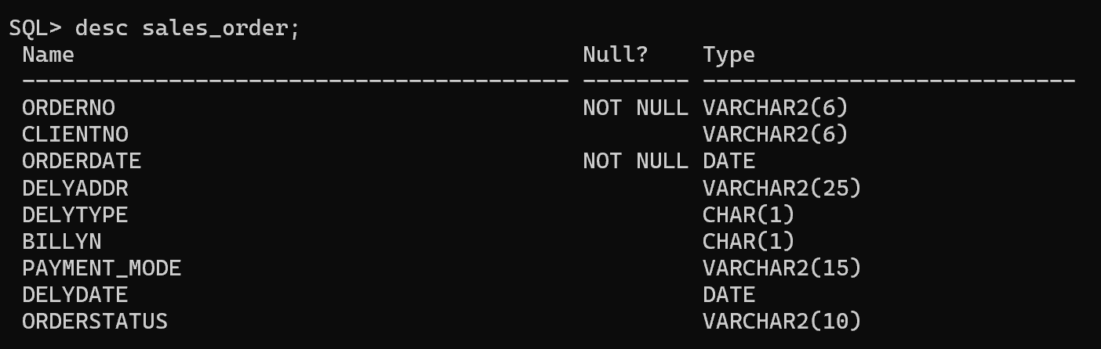

create table order_details
(
orderno varchar2(6) references sales_order(orderno),
productno varchar2(6) references prod_master(productno),
qtyordered number(8),
qtydisp number(8)
);
table order_details created.
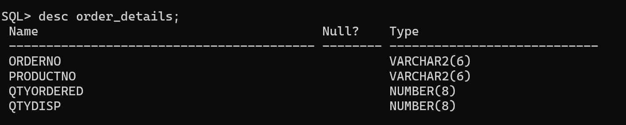

alter table cust_master add (telephone number(10));
table cust_master altered.
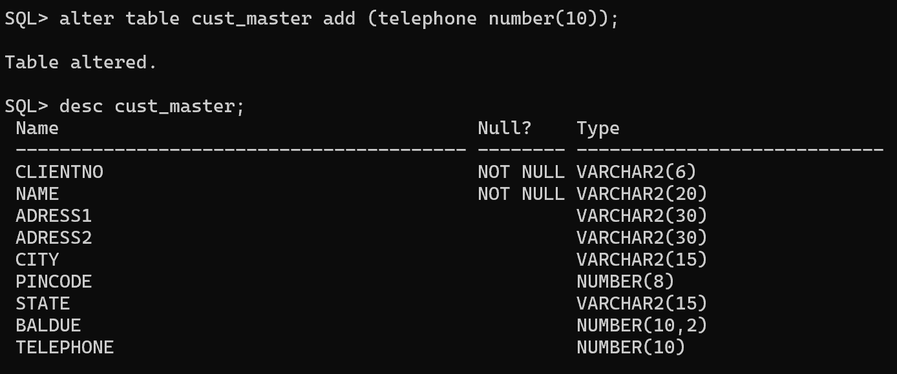

alter table prod_master modify (sellprice number(10,2));
table prod_master altered.
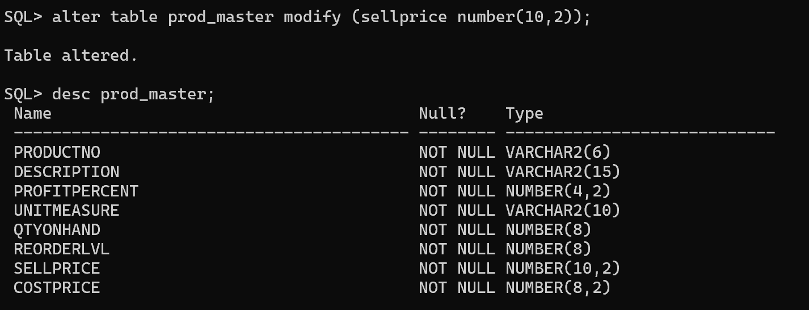

alter table order_details rename column
qtyordered to qtyord;
table order_details altered.
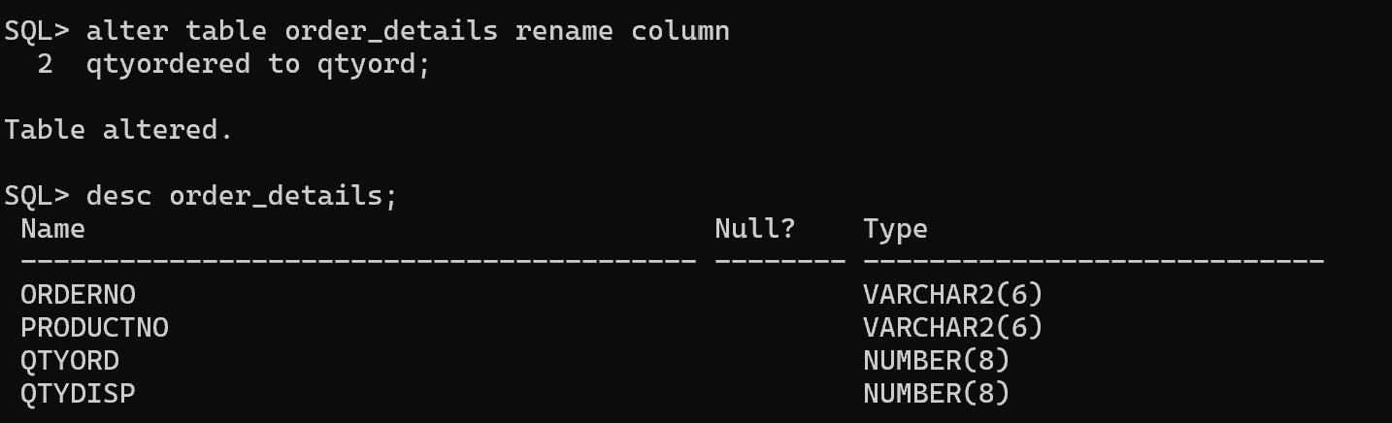

drop table order_details;
table order_details dropped.
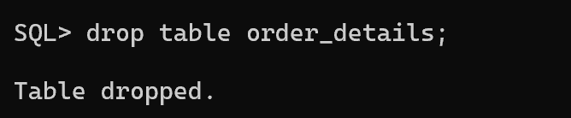
create table order_details
(
orderno varchar2(6) references sales_order(orderno),
productno varchar2(6) references prod_master(productno),
qtyord number(8),
qtydisp number(8)
);
table order_details created.
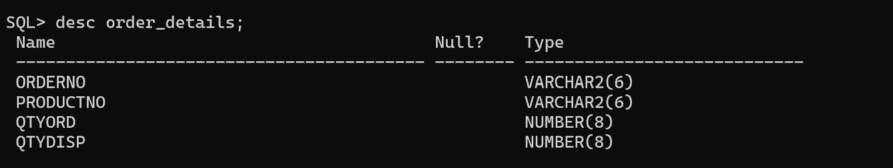

insert into cust_master (clientno, name, city, pincode, state, baldue) values ('C00001', 'Rahul Sharma','Mumbai', 400054, 'Maharashtra', 15000);
insert into cust_master (clientno, name, city, pincode, state, baldue) values ('C00002', 'Eric Sheldon', 'Madras', 780001, 'TamilNadu', 0);
insert into cust_master (clientno, name, city, pincode, state, baldue) values ('C00003', 'Rama Krishnan', 'Mumbai', 400057, 'Maharashtra', 5000);
insert into cust_master (clientno, name, city, pincode, state, baldue) values ('C00004', 'Evonne Eric', 'Bangalore', 560001, 'Karnataka', 0);
insert into cust_master (clientno, name, city, pincode, state, baldue) values ('C00005', 'Manasa Binu', 'Mumbai', 400060, 'Maharashtra', 2000);
insert into cust_master (clientno, name, city, pincode, state, baldue) values ('C00006', 'Ani Rose', 'Mangalore', 560050, 'Karnataka', 0);

6 rows inserted.
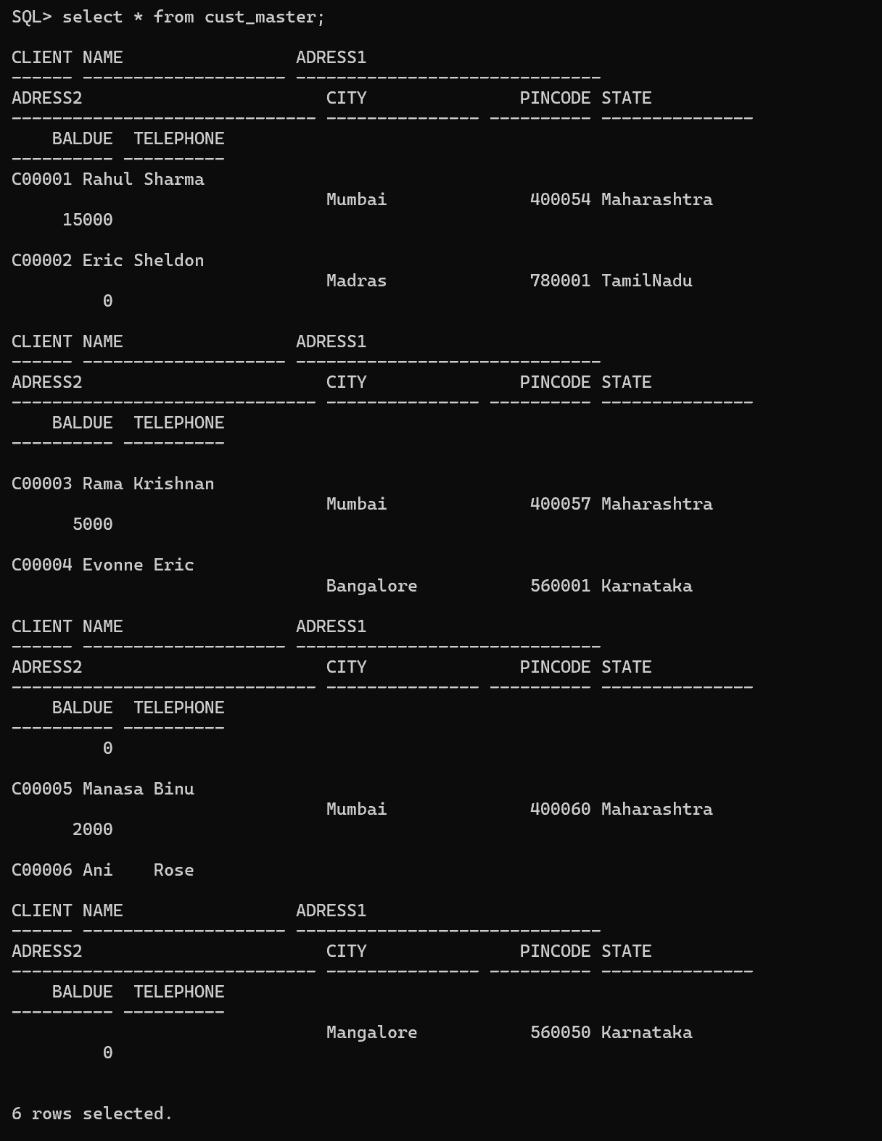

insert into prod_master values ('p00001', 't-shirts', 5, 'piece', 200, 50, 350, 250);
insert into prod_master values ('p03453', 'shirts', 6, 'piece', 150, 50, 500, 350);
insert into prod_master values ('p06734', 'cotton jeans', 5, 'piece', 100, 20, 600, 450);
insert into prod_master values ('p07865', 'jeans', 5, 'piece', 100, 20, 750, 500);
insert into prod_master values ('p07868', 'trousers', 2, 'piece', 150, 50, 850, 550);
insert into prod_master values ('p07885', 'pull overs', 2.5, 'piece', 80, 30, 700, 450);
insert into prod_master values ('p07965', 'denim shirts', 4, 'piece', 100, 40, 350, 250);
insert into prod_master values ('p07975', 'lycra tops', 5, 'piece', 70, 30, 300, 175);
insert into prod_master values ('p08865', 'skirts', 5, 'piece', 75, 30, 450, 300);

9 rows inserted.
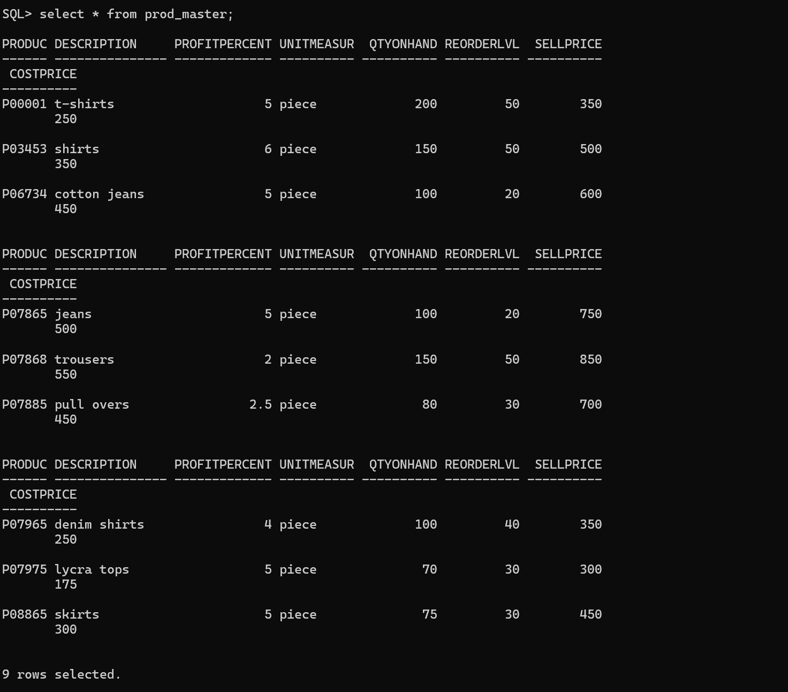
insert into sales_order values ('o19001', 'C00001', to_date('12-jun-2014', 'dd-mon-yyyy'), null, 'f', 'n', 'cod', to_date('20-jul-2014', 'dd-mon-yyyy'), 'in process');
insert into sales_order values ('o19002', 'C00002', to_date('25-jun-2014', 'dd-mon-yyyy'), null, 'p', 'n', 'cod', to_date('27-jun-2014', 'dd-mon-yyyy'), 'cancelled');
insert into sales_order values ('o46865', 'C00003', to_date('18-feb-2014', 'dd-mon-yyyy'), null, 'f', 'y', 'net banking', to_date('20-feb-2014', 'dd-mon-yyyy'), 'fulfilled');
insert into sales_order values ('o19003', 'C00001', to_date('03-apr-2014', 'dd-mon-yyyy'), null, 'f', 'y', 'credit card', to_date('07-apr-2014', 'dd-mon-yyyy'), 'fulfilled');
insert into sales_order values ('o46866', 'C00004', to_date('20-may-2014', 'dd-mon-yyyy'), null, 'p', 'n', 'debit card', to_date('22-may-2014', 'dd-mon-yyyy'), 'cancelled');
insert into sales_order values ('o19008', 'C00005', to_date('24-may-2014', 'dd-mon-yyyy'), null, 'f', 'n', 'net banking', to_date('26-jul-2014', 'dd-mon-yyyy'), 'in process');

6 rows inserted.
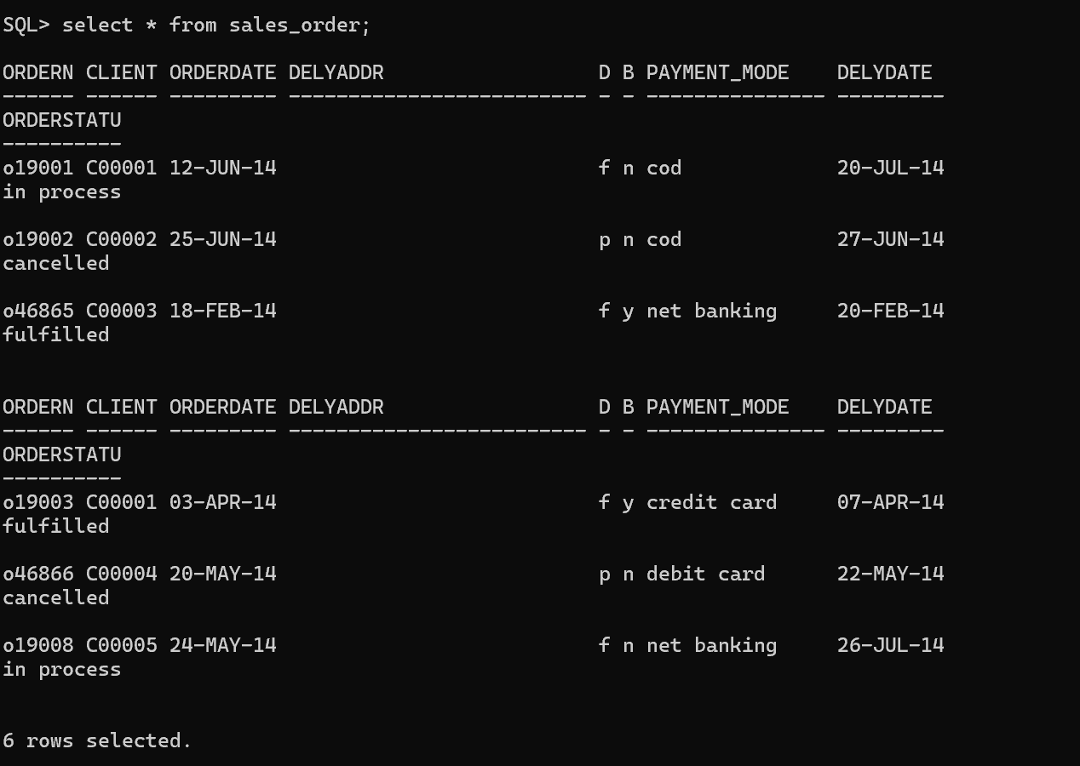

insert into order_details values ('o19001', 'p00001', 4, 4);
insert into order_details values ('o19001', 'p07965', 2, 1);
insert into order_details values ('o19001', 'p07885', 2, 1);
insert into order_details values ('o19002', 'p00001', 10, 0);
insert into order_details values ('o46865', 'p07868', 3, 3);
insert into order_details values ('o46865', 'p07885', 3, 1);
insert into order_details values ('o46865', 'p00001', 10, 10);
insert into order_details values ('o46865', 'p03453', 4, 4);
insert into order_details values ('o19003', 'p03453', 2, 2);
insert into order_details values ('o19003', 'p06734', 1, 1);
insert into order_details values ('o46866', 'p07965', 1, 0);
insert into order_details values ('o46866', 'p07975', 1, 0);
insert into order_details values ('o19008', 'p00001', 10, 5);
insert into order_details values ('o19008', 'p07975', 5, 3);
14 rows inserted.
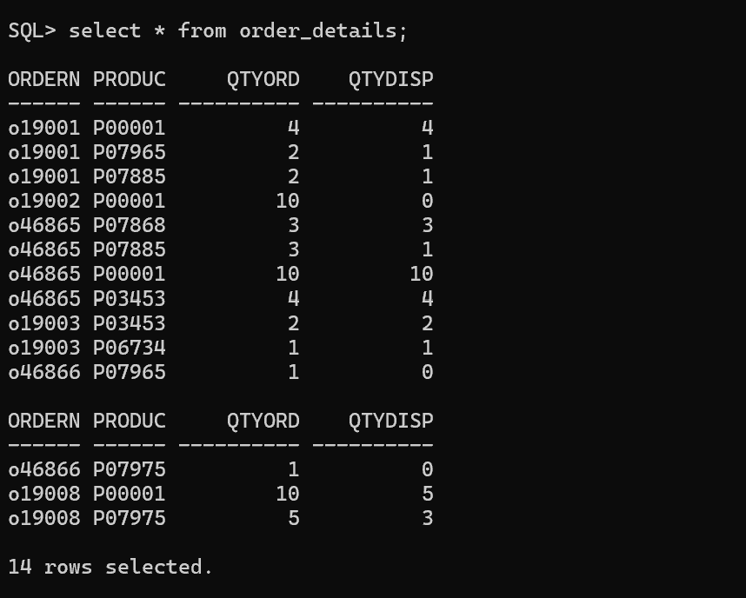

create table cust_temp as
select name as client_name, state, baldue
from cust_master
where baldue > 1500;
table cust_temp created.
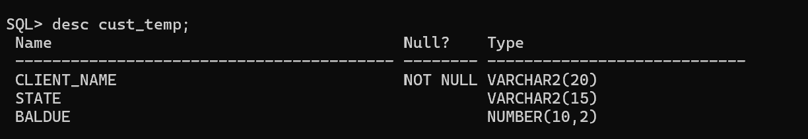

update cust_master set city = 'Bangalore' where clientno = 'C00005';
1 row updated.

update cust_master set baldue = 1000 where clientno = 'C00001';
1 row updated.
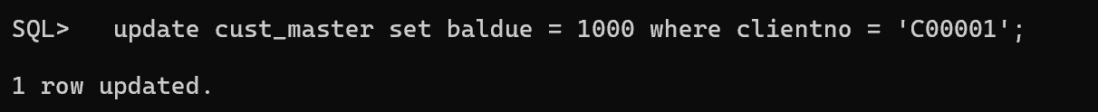
update prod_master set costprice = 950 where description = 'trousers';
1 row updated.

delete from order_details
where productno in (select productno from prod_master where qtyonhand = 100);
3 rows deleted.
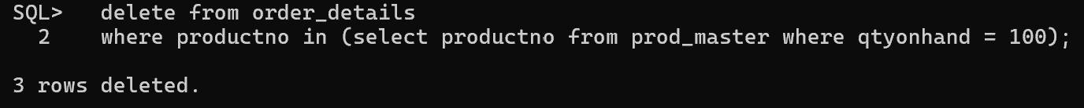

delete from prod_master where qtyonhand = 100;
3 rows deleted.
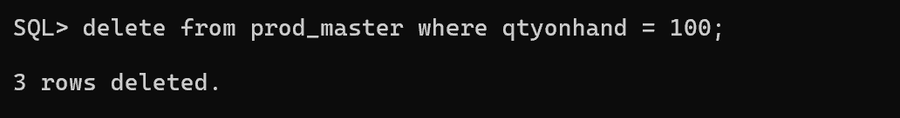

delete from cust_temp where state = 'karnataka';
0 rows deleted.
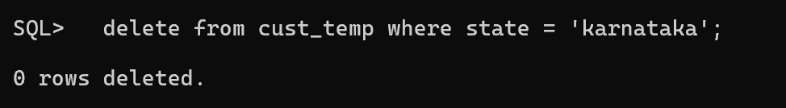

alter table cust_temp rename to c_mast;
table cust_temp altered.

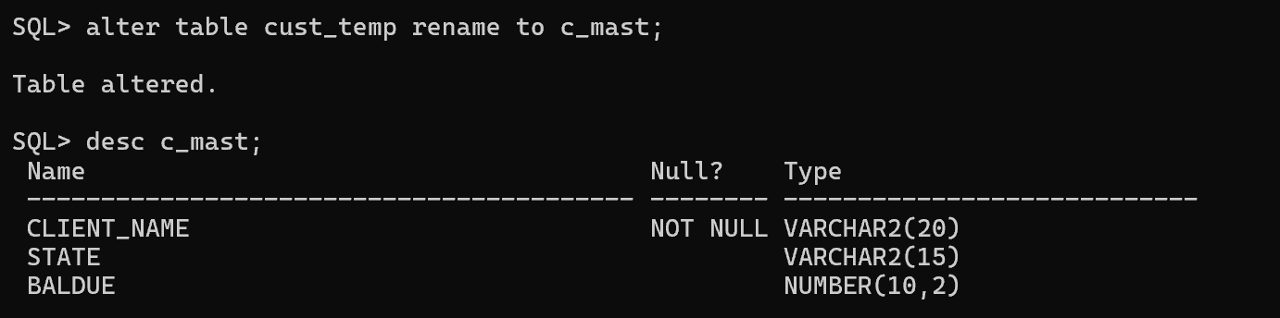

---------- END ----------

